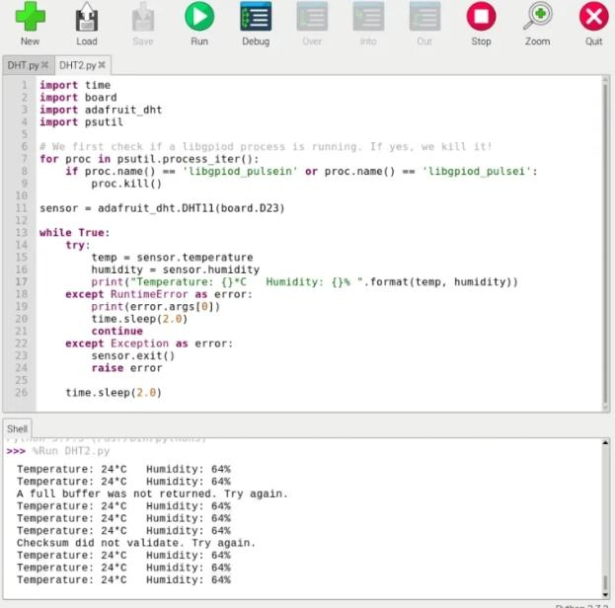 **TEMPERATURE AND HUMIDITY VALUES IN DETECT ALARM**